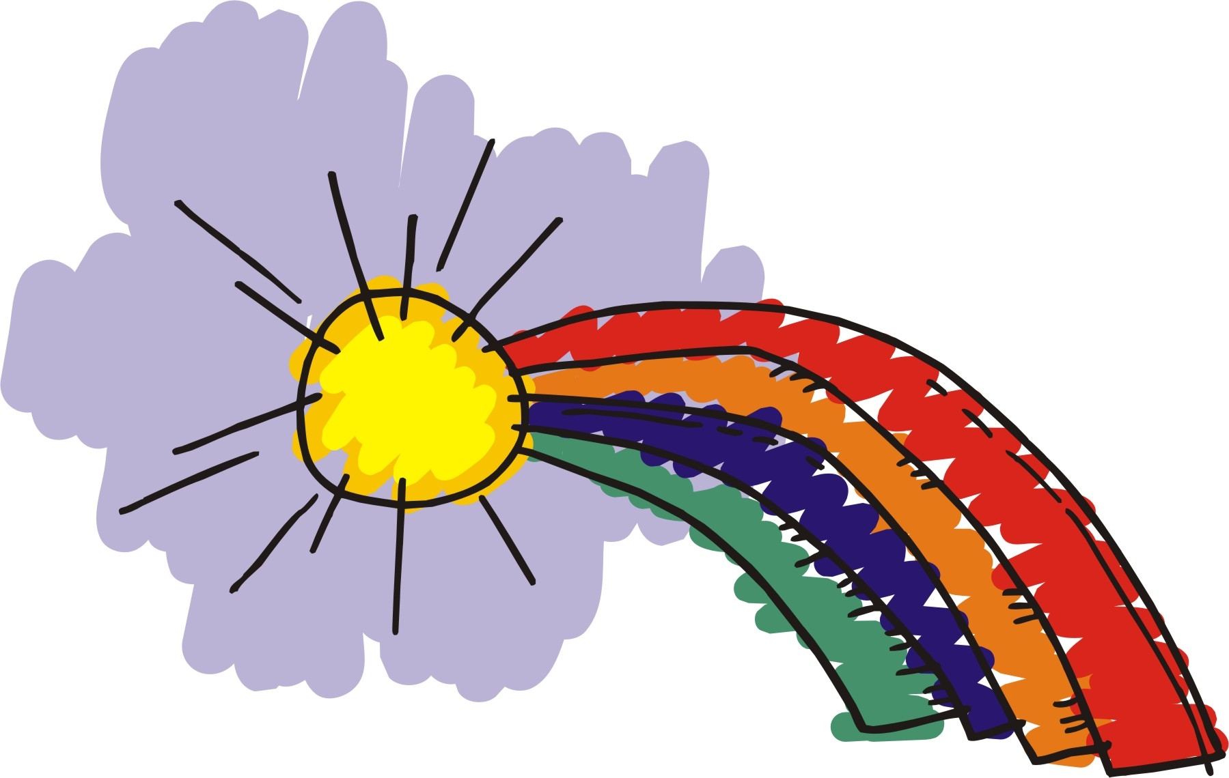
Rainbows

The Rainbows program is a support group for children who are dealing with a loss associated with a death in the family, a divorce/separation or a change within the family structure. When a child experiences a loss, he or she may experience a complex set of emotions known as grief. Some grieving children find it difficult to cope with these emotions. Therefore, the goal of the Rainbows program is to help children learn to put their feelings into words and begin to accept what has taken place within their family. Children will also understand that they are not alone and that there are other children dealing with similar emotions and experiences.

Rainbows groups typically consist of 2-5 students and an adult facilitator. These groups meet for approximately 16 sessions through out the school year during the child’s lunch and recess one day per week.

