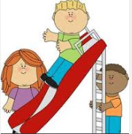 Friendship/Social Skills

Whether a new student to the district or trying to make new social connections, learning how to have successful friendships is a key component to one’s educational experience. Friendship/ Social Skills groups focus on building healthy social relationships. Skills taught may include, but are not limited to:
- Learning what a friendship looks like
- Initiating social interactions
- Advocating for self in social situations
- Identifying strategies for dealing with conflict
- Dealing with bossy behavior
- Finding common interests and making conversations

